Project Performance Test

Date | 14 July 2026
Team ID
Project Name | Food Ordering Behaviour and Consumer Trends
Maximum Marks | 4 Marks

Model Performance Testing:
Project team shall fill the following information in model performance testing template.
S.No. | Parameter | Screenshot / Values
 | Data Rendered | 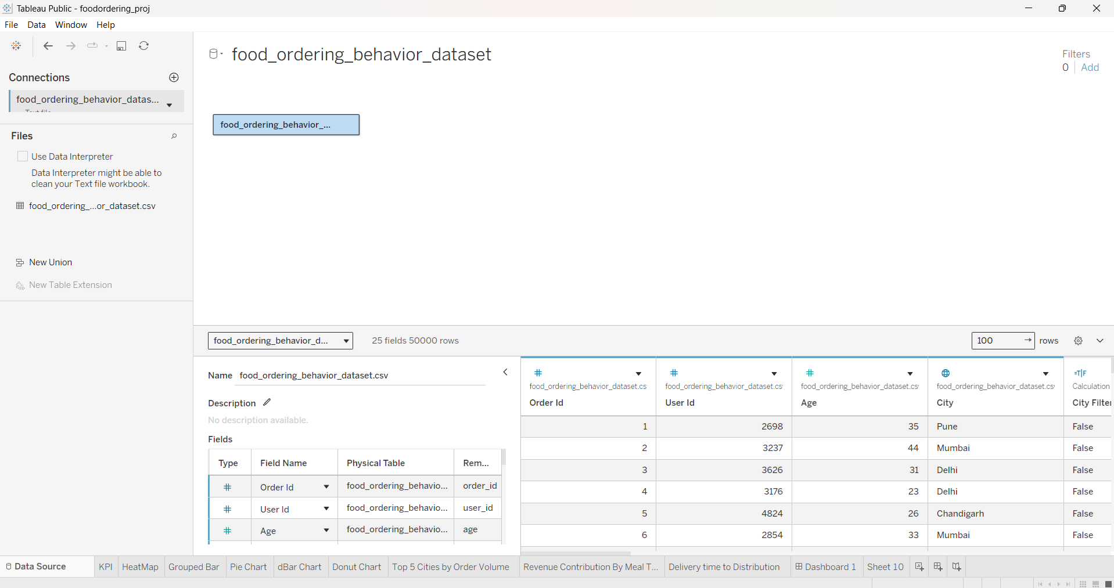  Dataset Loaded Successfully – 50,000 Records, 11 Attributes
 | Data Preprocessing | 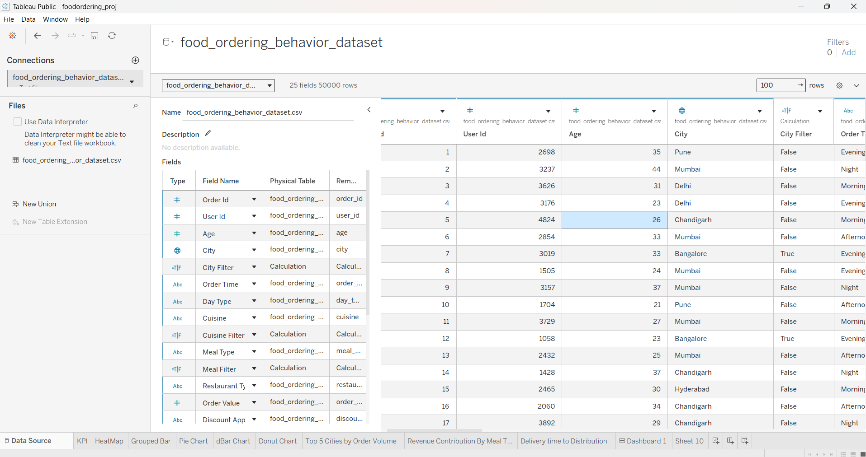  Dataset validated, missing values checked, duplicate verification completed, data types verified before visualization.
3. | Utilization of Filters | Interactive filters were implemented to allow users to analyze the dashboard based on different dimensions such as city, cuisine, meal type, and other available categories. These filters improve user interaction and support dynamic exploration of the data.
4. | Calculation fields Used | The dashboard primarily uses the dataset's existing measures and dimensions for analysis. It uses, Tableau's built-in aggregation functions to calculate summary metrics such as order count, average rating, and revenue.
5. | Dashboard design | No of Visualizations / Graphs – 9  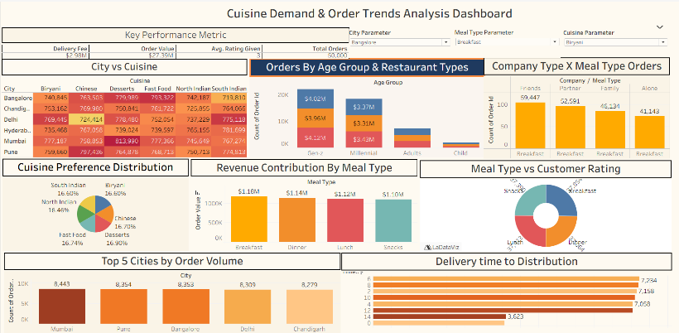
6 | Story Design | No of Visualizations / Graphs - 9

